Old Dominion University

CYSE 301 Cybersecurity Techniques and Operations

Assignment #1 Introduction to Linux Basic (2/3) & Explore Virtual Lab Environment

Name: Timothy Robinson

UIN: 01124784

# Module 0 – Lesson 4

Part A:

1. Rm command

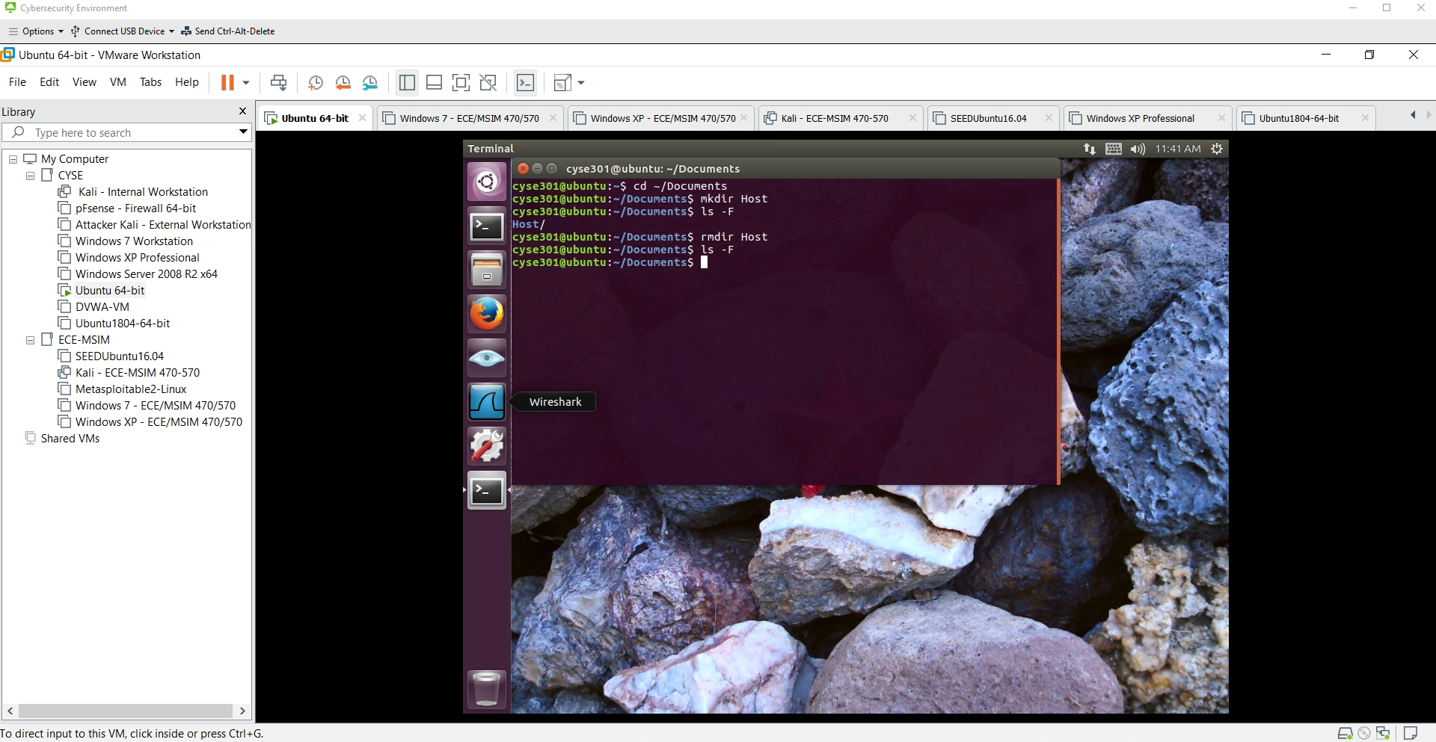

Figure : Practiced creating a new directory and then removing it in the Documents folder

1. Displaying Permissions

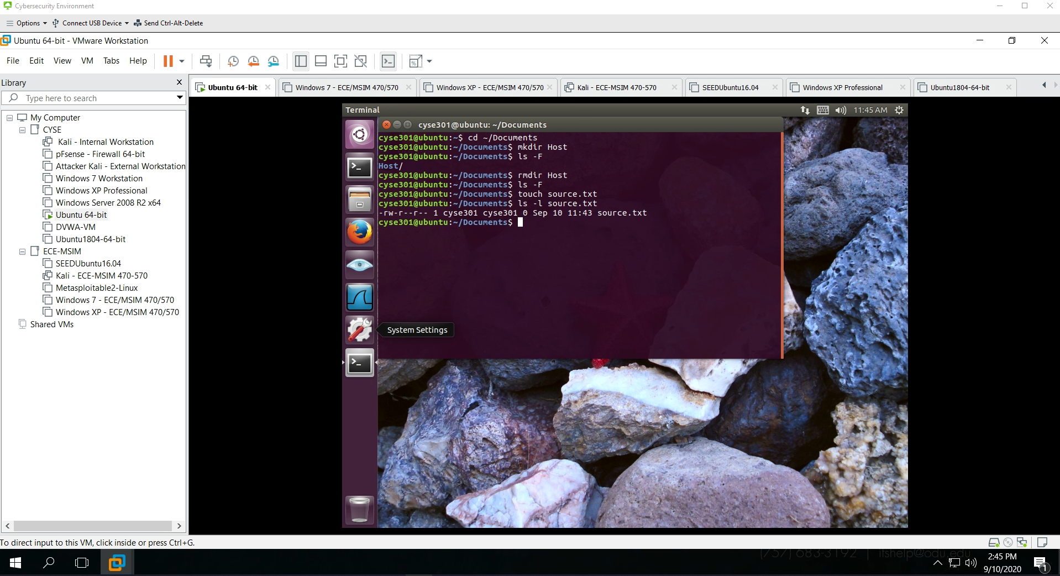

Figure : Takes a text file and displays the different permissions of that file

1. Symbolic Permissions

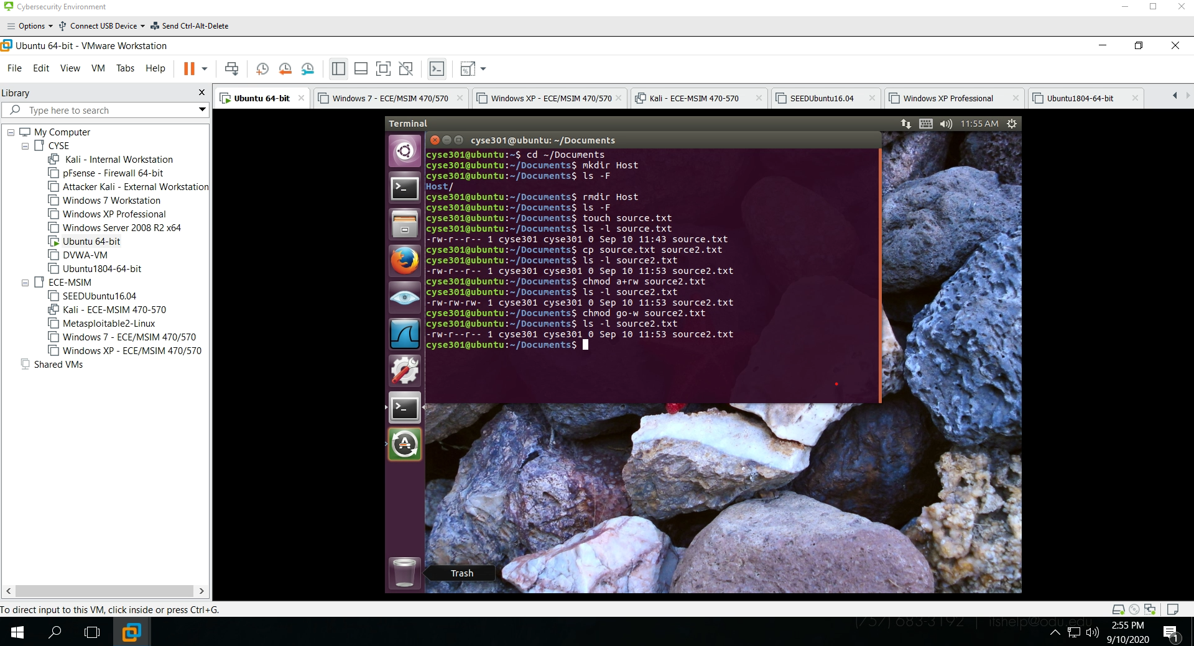

Figure : Practice changing the permissions for individuals on different levels

1. Absolute Permissions

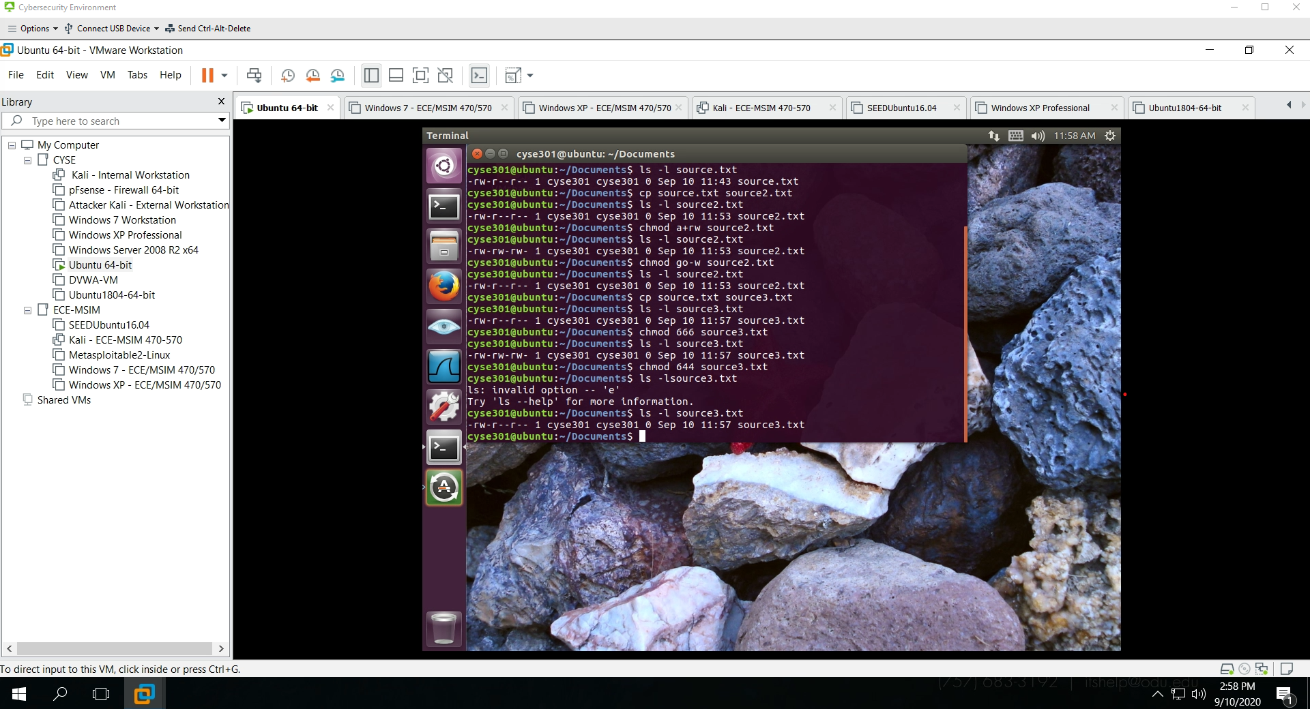

Figure : Practice changing absolute permissions for textfile source3.txt